**Assignment 1**

1. What is JDK? JRE? JVM?

JDK: Short for “Java Development ToolKit”,face to Java Developer. It contains JRE and a lot of Java tools like Javac/java/jdb and many important Java library.

JRE: Short for “Java Runtimme Enviromental”,all Java program must run in JRE. JRE contains JVM and Core library in Java and support files. Compare with JDK, JRE doesn’t have compiler,debugger and other tools, it only faces to the users to run Java Program.

JVM: Short for “Java Virtual Machinal”, JVM is a part of JRE,with its own hardware structure contains stack,CPU and registers.Only class file can be run in JVM(.class)

1. What is java compiler?

A Java compiler is a compiler for the programming language Java. The most common form of output from a Java compiler is Java class files containing platform-neutral Java bytecode.

1. Why is java platform independent?

With Java, you can compile source code on Windows and the compiled code (bytecode to be precise) can be executed (interpreted) on any platform running a JVM. So yes you need a JVM but the JVM can run any compiled code, the compiled code is platform independent.

1. What is IDE? Why is it important for developers?

IDE (integrated development environment) is a programming environment that has been packaged as an application program, typically consisting of a code editor, a [compiler](http://whatis.techtarget.com/definition/compiler), a debugger, and a graphical user interface ([GUI](http://searchwindevelopment.techtarget.com/definition/GUI)) builder.

1. Is java case sensitive?

Yes, same word in lowercase or uppercase has different means.

1. What do the following key words do?  static, final, public, private, void, null, package, Class, new

static:static variable belong to the whole class, can’t be changed after execution. Static method belong to the whole class, can be called without create a new object. Static block only excute once when the class file load into JVM.

final:final variable can’t be changed.final method can’t be overriding.final class can’t be extended.

public:   A class, method, constructor, interface etc declared public can be accessed from any other class. Therefore fields, methods, blocks declared inside a public class can be accessed from any class belonging to the Java Universe.

However if the public class we are trying to access is in a different package, then the public class still need to be imported.

Because of class inheritance, all public methods and variables of a class are inherited by its subclasses.

private: Methods, Variables and Constructors that are declared private can only be accessed within the declared class itself.

Private access modifier is the most restrictive access level. Class and interfaces cannot be private.

Variables that are declared private can be accessed outside the class if public getter methods are present in the class.

Using the private modifier is the main way that an object encapsulates itself and hide data from the outside world.

void: void mean a method won’t have a return value

null:the value of a variable doesn’t exist.

package: A Java package is a technique for organizing Java classes into namespaces similar to the modules of Modula, providing modular programming in Java. Java packages can be stored in compressed files called JAR files, allowing classes to be downloaded faster as groups rather than individually.

class: A class is nothing but a blueprint or a template for creating different objects which defines its properties and behaviors. Java class objects exhibit the properties and behaviors defined by its class. A class can contain fields and methods to describe the behavior of an object.

new: use new keyword when create a new object, will call the constructor of the class it belongs to, if no constructor, system will build a default one.

1. What is primitive type and reference type?

In Java, every variable has a type declared in the source code. There are two kinds of types: reference types and primitive types. Reference types are references to objects. Primitive types directly contain values. There are 8 primitive types: byte,short,int,long,char,float,double,boolean.

1. Is parameter passed by value or reference?

All parameter pass in Java are by value, that means Java create a copy of the parameter then pass the value of copy, so the original parameter’s value won’t be change.

1. What is the output: System.out.println(1 > 0 : “A”:”B”);

“A”

1. How to define constants in java?

final static datatype valuename = constant;

1. What is String? Is it primitive type?

String is a data type used to represent a string of characters.

String is not a primitive type, It is known as a reference type,but can be used like a primitive type without using a new keyword when create a new string.

1. How to check if a String is representing a number?

Use Double.parseDouble(string) to convert string to double type if catch an exception then this string is not a number.

1. Write a program to implement the following activity diagram:

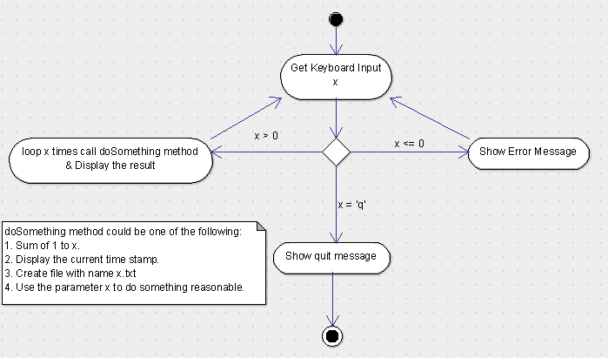

**package** net.antra.dayone;

**import** java.util.Scanner;

**public** **class** TestInput {

**public** **static** **void** main (String[] args) {

TestInput res = **new** TestInput();

**try**(Scanner scanner = **new** Scanner(System.***in***)) {

**while** (**true**) {

String str = scanner.next();

**if**("q".equals(str)) {

**break**;

}**else** **if**(Integer.*parseInt*(str) <= 0) {

System.***out***.println("Input error!");

}**else** res.doSometing(str);

}

}**catch**(Exception e){

System.***out***.println("error!!!");

}

}

**public** **void** doSometing(String str) {

**int** num = Integer.*parseInt*(str);

**int** sum = 0;

**for** (**int** i = 0;i <= num;i++) {

sum += i;

}

System.***out***.println(sum);;

}

}